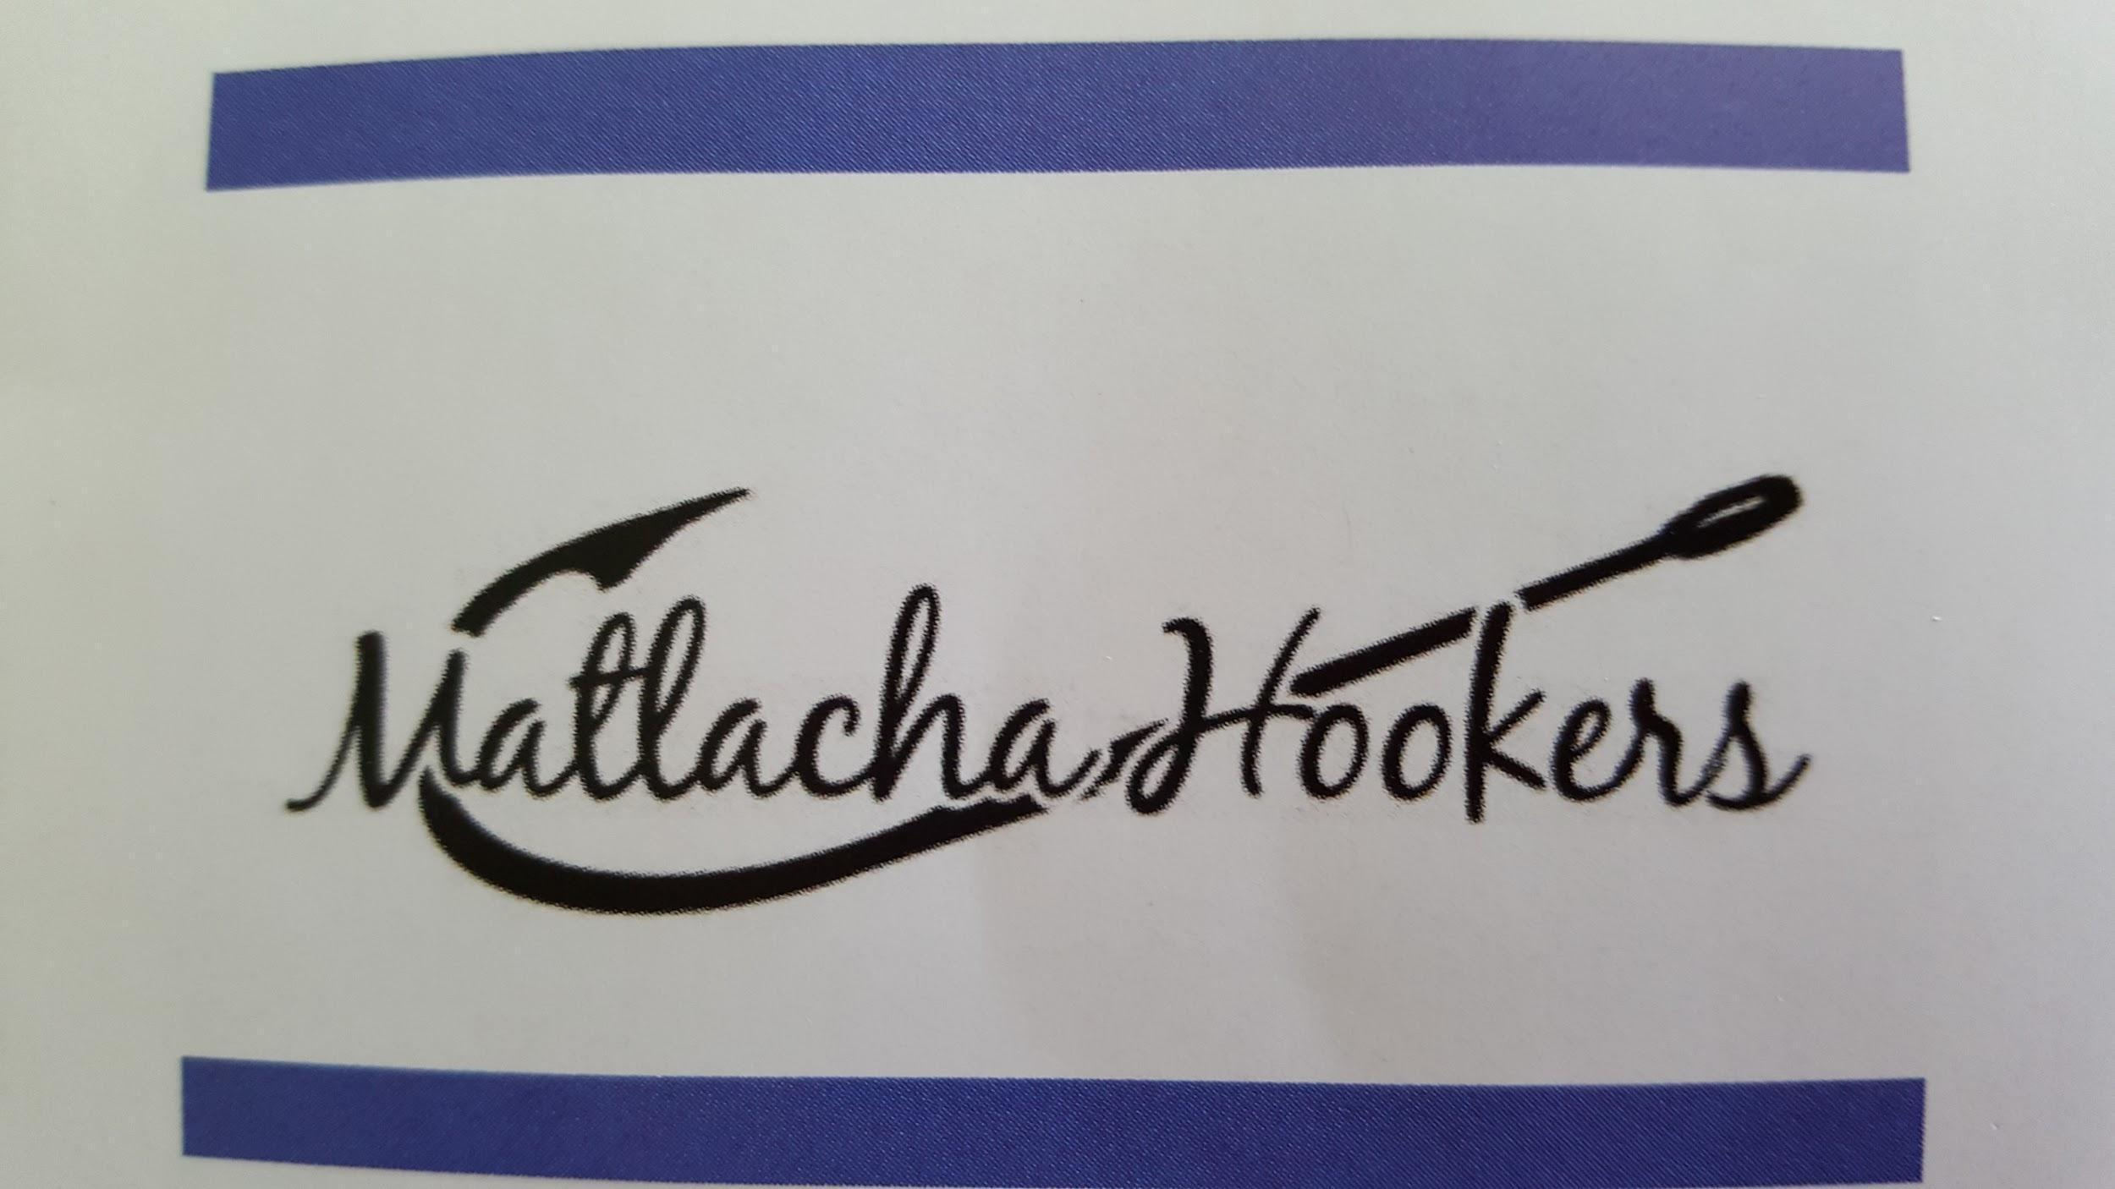

MATLACHA HOOKERS
GENERAL MEETING AGENDA
August 9, 2021

Call to Order by Madam DJ at
Pledge of Allegiance led by Madam DJ
Invocation by Anita Jannotti, Chaplain

BOARD REPORTS
Madam DJ Ruscik
a) 50/50: Captains for Clean Water or ??
b) Hooker Business: IRS Update
c) Fundraising: Opportunities
- Cruise Raffle
- Cape Coral Community Foundation Grant – Training session on August 26th at 9:30am-Julia
- Winn-Dixie Community Bag Program – November
d) Financial Requests: None
e) Dues are due in October!
f) American Legion Auxiliary – Borrowing equipment – Back to School Family Carnival, Saturday, August 29th Noon to 4:00pm

Vice Madam Julia Simpson, Membership
a) Membership Report:
b) Meeting Attendance:
c) New Member swear-in
d) Call Girls Thank You and next month’s volunteers:
e) Birthday celebrations!
f) Elections – Nominations in September and October, election in November.
g) New Membership Application and Name Tags
h) Final Pampered Chef results

Secretary, Tara Efird
a) Review and approval of general minutes
b) Online Votes
c) Mail
d) Hooker Heralds - Submission deadlines for committee chairs – August 18th for the Herald on the 20th, and August 28th for the Herald on the 30th.

Treasurer, Terry Batdorf
a) Review and approval of financial reports

Chaplain, Anita Jannotti
a) Chaplin Report
b) Outreach Report
c) Budget and financial need discussion

EVENTS AND ACTIVITIES:
1.Fundraisers

- Merchandise Report:
- PIE Derby - Next meeting, Monday, August 23rd at 6:00pm where??
- ArtFest – 2022 is the last year the Theresa and Lorie will Co-Chair
- Wine Event – Next meeting, Monday, August 16th at SJCC at 6:00pm

2. Community Support
a) Adopt-A-Road – Saturday, August 21st with the Boy Scouts
b) Blood Drive – Great turnout on August 7th, the next drive in November. Thank you from Gina! (Outreach)
e) School Supply Drive – DONE! Principal Tom will be attending the September meeting and we’ll be presenting a check for additional funds collected - DJ
f) F.I.S.H Clothes for Kids – Tara and Anita
g) Pine Island Food Pantry needs – Always check the Heralds

OTHER:
50/50 collected $ Tonight’s winner:
Tonight’s donation to Food Pantry $
Next Board Meeting – Thursday, August 26th at 6:00pm at Little Lilly’s Deli
Next General Meeting:
Meeting adjourned @

