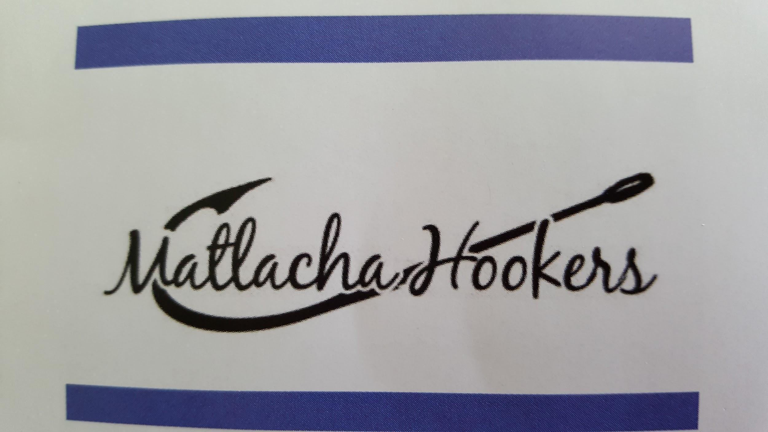

MATLACHA HOOKERS
GENERAL MEETING MINUTES
April 12, 2021
Call to Order by Madam DJ at 6:00pm
Pledge of Allegiance led by Madam DJ
Invocation by Anita Jannotti, Chaplain

Guests: Nancy from the Beacon of Hope, and William and Carlos from CW Fudge

ArtFest Scholarship Fund Presentation via GoToMeeting. Three guests representing ArtFest Ft. Myers called into the meeting online. Lorie Tidwell gave a short presentation explaining that this was the 20th year the Hookers were the beverage team for the event. This year, ArtFest Ft. Myers made the decision to donate $1,600 towards a scholarship. The Hookers will add $400 to complete a scholarship from ArtFest Ft. Myers.

Beacon of Hope check presentation and Wine Event recap. Nancy from the Beacon of Hope attended in-person and the Hookers presented a check to the Beacon for $8,000. Joanne Correia gave a 2021 event recap stating that this year’s event was a success and sold out. The next meeting is June 21, 2021 at the St. James Civic Center. The 2022 event is tentatively scheduled for February 27th. Joanne also presented t-shirts to William and Carlos from CW Fudge as a Hooker Hug and thank you for all of their support of the event.

BOARD REPORTS
Madam DJ Ruscik

DJ announced to the group that Julia Simpson and Chris Buntin have stepped up to fulfill the open positions of Vice Madam and Director, respectively.
a) 50/50: Randell Research Center. DJ explained that each year we make a donation to the research center, but we have not done that in a while. Lorie Tidwell made a motion to give this month’s 50/50 money to Randell Research. The motion carried.
b) Fundraising:
- Model Boat Building Activity. We were contacted by a company that makes model boat kits. They have a fundraising opportunity at the upcoming Nautical Expo in May. The Hookers would purchase the kits (price unknown) and then run an event for kids to build and race boats. The Board decided to table this opportunity to gather more information.
- Pampered Chef Party. Julia had the idea that we could run a Pampered Chef party like we did many years ago. We can host the party for only members or we can open it up to the public. Julia is looking into details. DJ reminded the group that our general fund needs replenishment.
c) Financial Requests:
- Pine Island Elementary Playground Fundraiser. The school is getting replacement playground equipment and is asking for community support to purchase extras such as sunshades. Principal Tom has agreed to allow us to do a pancake breakfast in the summer to raise money for these extras.
- Annual Chamber of Commerce Golf Tournament. The Hookers have been asked to sponsor a hole for $100. The event is Saturday, April 17th. Linda Bohacek made a motion for the Hookers to be a sponsor. The motion carried.
d) Best of Pine Island Voting. Last year the Hookers got the Best of Pine Island for service organization. DJ reminded the group that the postmark deadline for voting is Friday, April 16th. Ballots must contain at least 25 categories to be valid. Ballots can also be dropped off at the Pine Island Eagle office.
e) Girls Night Out
The event is scheduled for Monday, April 26th at the Olde Fish House. Theme and Time TBD.
f) Annual Solicitation and Sunbiz renewals have been completed per DJ.
g) Expanding the Board to Part-Time Seasonal Remote Participation. Expanding the Board to allow for Remote participation because we are now utilizing telecommunication technology for our meetings. The discussion of full-time versus part-time seasonal Board Members can now remotely participate in all meetings. The Bylaws currently don’t allow for part-time residents. There must be two months’ worth of discussion must be had before changes can be added to the ballot. Joanne Correia made a motion that we vote to allow seasonal members on the Board of Directors. After discussion, the motion carried with one opposed. DJ requested that the minutes of this meeting be sent to attorney Kevin Kile for the Bylaw amendment to be drafted.

Vice Madam Julia Simpson, Membership.
Julia was unable to attend the meeting. Billie Young filled in for Vice Madam.
a) Membership Report: Billie didn’t have the information with her as she had already transferred it to Julia.
b) Meeting Attendance: There were 39 in attendance with six guests and five new members.
c) New member swear-in: Five new members were sworn-in but were not lei’d as the supplies weren’t present.
d) Call Girls Thank You and next month’s volunteers: Shirley Noble and Jeannie Glen volunteered to be the May Call Girls.
e) Birthday celebration!
f) Billie recognized the members that help with Beacon Bites for The Beacon of Hope.

Secretary, Tara Efird
a) Review and approval of March general minutes. Linda Bohacek made a motion to approve the March general meeting minutes. The motion carried.
b) Online Votes
- Tara informed the group that the only online votes were for the Board to approve the new Vice Madam, Julia Simpson, and new Director, Chris Buntin. The approval motion was made by Jill Filgut and passed with six approve votes.
c) Mail. No additional mail.
d) Hooker Heralds - Submission deadlines for committee chairs are April 8th, 18th, and 28th.

Treasurer, Terry Batdorf
a) Review and approval of financial reports. February financials have been posted to the website. A motion was made by Sandy Kerr to approve the February financials. The motion carried.
Terry explained that she needs help with administrative stuff if you are making a deposit to the bank account. Please be very detailed with what fund the money should go to into and add your name to the deposit so Terry can contact you if she has questions. If you are able, please deposit your funds into the specific account (such as for the Wine Event or PIE account) instead of into the general fund. Terry explained she is still new and learning. She also said that if you scan a copy of a deposit slip to her, she doesn’t need the physical copy also.

Terry reported a total of $53,000 in all accounts with the highest balance being in the Money Market account.

Chaplain, Anita Jannotti
a. Chaplin Report.
b. Outreach Report. No outreach information. The group was reminded that we communicate with Beacon of Hope, FISH and other organizations to make sure the community is being served the best way possible.

EVENTS AND ACTIVITIES:
1.Fundraisers
- Bag ‘n Tag Recap. The chairs reported a great event. DJ gave a big thank you to all that donated and helped run the event. The remaining items that didn’t sell were donated to PICC. DJ explained the committee kept Christmas items in preparation for the Holiday Bazaar at the Catholic Church, and we’ll be able to make a couple Christmas baskets for the Derby. Last year the event raised $3,200 and this year it raised $3,400 for the scholarship fund.
- Scholarships. Chris Buntin updated the group that last Friday was the deadline for applications. The committee is meeting this Wednesday to choose the winners. Chris states we are fully funded. The scholarship presentation will be at the general meeting on May 10th.
- Merchandise Report: Linda Bohacek reminded the group that all merchandise sold supports the general fund. We are now selling jam and mustards and just got in the ArtFest T-Shirts. We raised $2,062 in March from merchandise.
- PIE Derby Kickoff Meeting. The event will be at the Olde Fish House and is tentatively set for November 7th. The committee will meet for the kickoff on Tuesday, April 27th at 6pm. Location TBD.

2. Community Support
a) Adopt-A-Road – Next clean-up is Saturday, April 17th. Meet behind the Olde Fish House at 8:30am. More help is needed.
b) Blood Drive – The next blood drive is Saturday, May 1st at Miceli’s from 10am until 4pm. Online reservations will be taken. Drives have been booked solid in the past so this drive has been extended a full hour.
c) Mango Mania – More information to follow on potential ideas for this year.
d) 4th of July parade – DJ said permitting is being requested for a parade to be held this year.
e) School supply drive – Karen Durand has volunteered to Chair once again!
f) F.I.S.H Clothes for Kids. We will talk more about this in June. Anita Jannotti and Tara Efird will co-chair.
g) Pine Island Food Pantry needs – DJ reminded the group that we are all asked to either bring two requested items to the general meeting or make a monetary donation.
h) DJ happily announced to the group that she was awarded the 110 award at the Bobby Holloway Jr. Memorial Fishing Tournament.
i) DJ also announced that the Hookers have been chosen as PIE’s Business Partner of the year and DJ will attend a presentation downtown with Principal Tom.

OTHER:
50/50 collected $98 for the Randell Research center and $97 for winner. DJ stated we would round the Randell Research donation up to $100. Tonight’s winner: Sandy Lolly
Tonight’s donation to Food Pantry $85 in cash.
Next Board Meeting: Monday, May 3rd at Little Lilly’s Deli - 6pm
Next General Meeting: Monday, May 10th at the House of Omelets on Pine Island Rd - 6:30pm Scholarship Presentation!!! Will be focused on Scholarship presentation so business will be short.
Meeting adjourned @ 7:59pm. Billie Young made a motion to adjourn. The motion carried.

