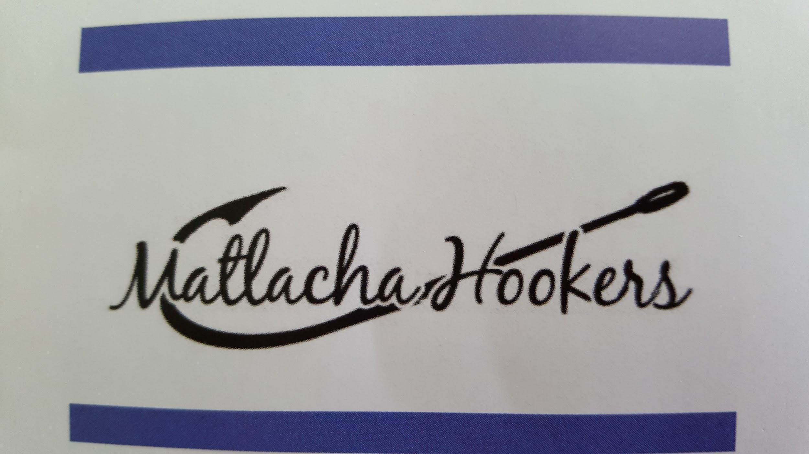
BOARD MEETING AGENDA
May 3, 2021

Call to Order by Madam Deja Vu Deux at Little Lilly’s Deli 6 p.m
Attendance: Jill Filgut, Beth Nelson, Lucinda Good, Monica Kochel, Teri Batdorf, Julia Simpson, Chris Buntin, DJ Ruscik, Joanne Correia, Anita Jannotti, Tara Efird
Absent:

BOARD REPORTS
Madam DJ Ruscik

a) 50/50:
b) Fundraising:
- Boat kit fundraiser
- Pampered Chef
c) Financial requests:
- Kayak Camp scholarship

By-Laws to attorney for revision

Vice Madam, Membership

a) Membership report:

Secretary, Tara Efird

a) Review and approval of board minutes
b) Online Votes
c) Read Mail
d) Hooker Heralds-issue date and submission deadline for next 3 issues

Treasurer, Terry Batdorf

a) Review and approval of financial reports

Chaplain, Anita Jannotti

a) Chaplain report
b) Outreach report

EVENTS AND ACTIVITIES
1: Fundraisers
- Scholarships - May
- Merchandise Report:
- PIE Derby – November

2: Community Support
a) Adopt-A-Road:
b) F.I.S.H. Clothes for Kids:
c) Blood Drive:
d) School supply drive:
e) Pine Island Food Pantry needs:
f) Mango Mania:
g) 4th of July parade:

OTHER:
Next Board Meeting: Monday,
Next General Meeting:
Meeting adjourned at

